Budgetwise
Week 6 | 3/14/2026 - 3/27/2026

Leader: Marcelo Mejia

Sophia  Time Spent  13 hours | Tasks completed:  - Updated team leader rotations  - Consolidated documents to give to TA  - Changed AI integrations from Gemini to OpenAI models on Groq  - Implemented AI-optimized budget comparison feature  - Limited tokens used during requests so that I can effectively test everything  - Before:  - 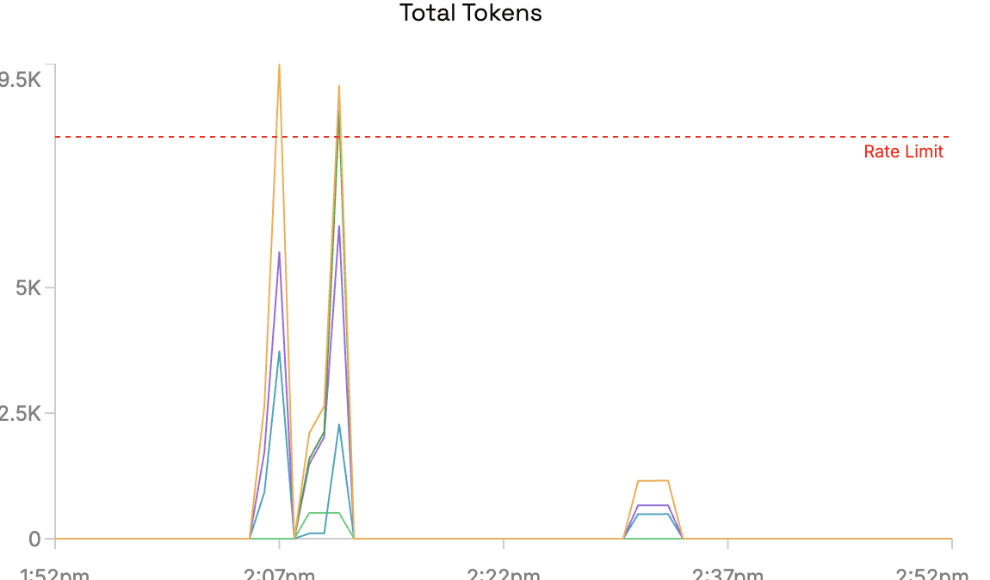  - Changed model order that I use for AI features to default to llama (better rates)  - All changes are on ai-features branch  Planned tasks for next week:  - Debug short recommendations  - Add AI budget recommendation on budget creator page  Any issues or challenges:  - 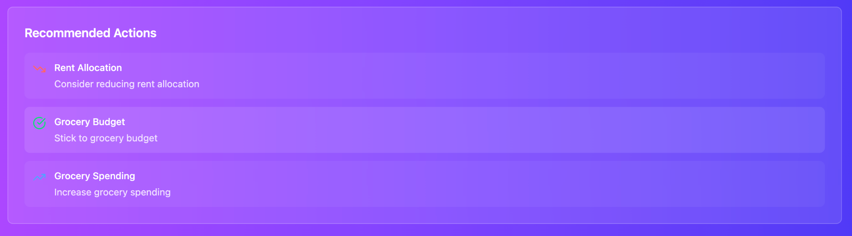  - The recommendations are now very short. I think this is because I limited the token usage. I will need to play around with parameters so that I can get better recommendations without going over the rate limit
Jonathan Gruber  Time Spent  30 hours | Tasks completed:  - Back end for forgot-password and reset-password functionality.  - Update architecture diagram.  Planned tasks for next week:  - Help to link front- and back-end portions of forgot-password and reset-password functionality.  - Maintain architecture diagram.  - Research details for SMTP server to be used for sending reset-password email.  Any issues or challenges:  - Authentication and connection details for SMTP server to be used for sending reset-password email.
Marcelo Mejia  Time Spent  12 hours | Tasks completed:  - Added and updated tasks for the team in Jira  - Merged other team member branches into front_back_merge  - Added a feature that allows for running the app in dev:mock mode.  - Command we have been using: npm run dev  - New available command: npm run dev:mock  - This command imports the values from the mock data spreadsheet into the database, and creates a “fake” user to associate with this data (credentials for this user are given in the terminal upon running the command).  - With this feature, hundreds of values are automatically imported into the app and contribute to what is shown in the expenses, calendar, and dashboard pages.  - Adding the mock data added some issues to be fixed:  - The expenses page would be time-synced to show the income/expenses of the current month, even if there were values for later months (for example, it would show the monthly stats for March 2026 even if the mock data added values for September 2026). Fixed this by making the expenses page match up with the month of the most recently added item.  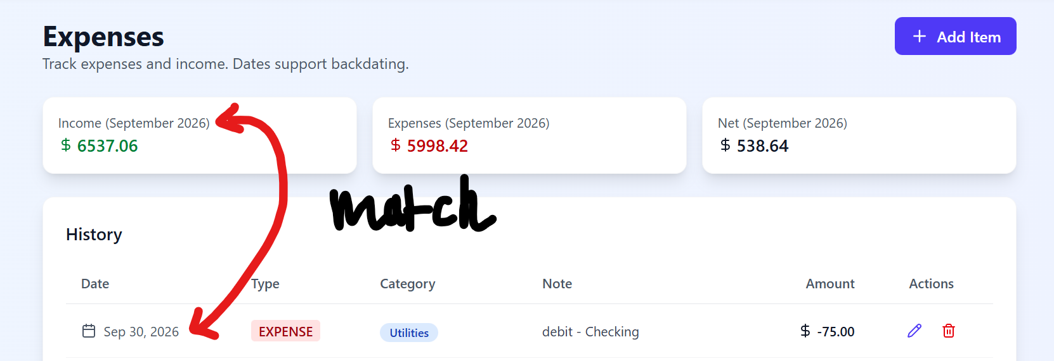  - Minor bug fixes regarding the budget creator and dashboard pages showing the same values.  Planned tasks for next week:  - Introducing the mock data gave me a perspective of what the app would realistically look like with a real user in its current state. Because of that, there's some testing, bug fixes, and beautification related to the entire app that I would like to engage in. I also plan to add any last features from our project specs that haven’t been attended to yet so that we can focus less on implementation and more on testing going forward.  Any issues or challenges:  - Merging branches took some time, mostly from resolving conflicts and making sure the new merged version of front_back_merge ran correctly.  - While adding the command to import the mock data took little time, the issues it brought along with it took some time to fix.
Casandra Marquez  Time Spent  12 hours | Tasks completed:  - Created a basic email reset to update the database as a temporary solution to fall back on until password reset is finished  - Database optimization  - Researching Docker and starting that set up to migrate database from SQLite to PostgreSQL  - Set up initial Docker container locally  - https://www.youtube.com/watch?v=Ud7Npgi6x8E&t=290s  - Created a notes doc to prepare for next week’s migration  - https://docs.google.com/document/d/1VQnU_ckqqQ6RohR8fNVXK-lWkAG4XSEjknAIxmWQGt8/edit?usp=sharing  - Work on CI/CD  - Looking into how to set up CI to help in deployment when we’re done  - Creating GitHub CI.yml and workflow configurations after resolving merge conflicts  - https://docs.google.com/document/d/1VkwDstQ6YLblhOGQ5YrzlvPWPUInRdVpPMJgX6OIfpA/edit?usp=sharing  - Started merging my work with the current update of front_back_merge  Planned tasks for next week:  - Complete merge conflicts are resolved  - Finish adding CI.yml workflow configurations  - Migrate from SQLite to PostgreSQL to start working on deployment  - Edits under optimization opportunities  Any issues or challenges:  - Merging conflicts before working on migrating database  - Learning how CI/CD works, Docker set up
Jonathan Strong  Time Spent  11 hours | Tasks completed:  - Fixed slight issue with normal dashboard and bar chart.  - They did not show all of the categories and the bar chart did not show the expenses  - Created list of Test Cases  - During testing I noticed add expense categories did not match all categories in other pages  - Need to update categories to be consistent  - During testing I noticed that the budget creator portion behaves strangely  - Specifically it won’t allow the user to increase the budget for any category so the user is only able to decrease the budget causing any excess percentage to automatically be allocated to other or not change the recommended budget  - https://docs.google.com/spreadsheets/d/1vOoeru3KVPgzfKPksLUyNN6EUk7s1ceKKEgNK8J5trw/edit?usp=sharing  Planned tasks for next week:  - Ensure that the amount of categories is clear and consistent  - Change the budget creator so that it will allow for users to modify the percentages or amounts freely  - If the user has an invalid budget such as using more than the budget or less then it will require to user to update the budget until exactly 100% of the budget is used  - Also make it so that whenever you decrease the budget of a certain section the amount you decreased it by does not get added to other  Any issues or challenges:  - Slight issues after downloading latest version but was able to fix and get started
Haru Kimura  Time Spent  8-9 hours | Tasks completed:  - Kept up with team updates and merge progress to stay aligned with backend changes  - Built off the forgot password UI I worked on last week by looking into how it will connect to the backend reset-password functionality  - Researched how frontend and backend integration works in Next.js, especially for handling things like password reset flows and API calls  - Looked into handling dynamic data in the UI (like budget categories and percentages) to prepare for upcoming fixes  - Started identifying areas in the frontend that will need updates once everything is fully merged (budget creator, dashboard inconsistencies, etc.)  Planned tasks for next week:  - Connect the forgot password UI to the backend reset-password functionality once it’s fully set up  - Start implementing frontend changes after the merge stabilizes  - Fix UI issues like category consistency and dashboard display problems  - Help test and debug frontend-backend interactions  Any issues or challenges:  - Ongoing merge work made it hard to safely implement changes without conflicts  - Some backend features (like password reset) are still being finalized, so I’m waiting to fully connect everything

Total Time Spent: 87 hours

Summary:

